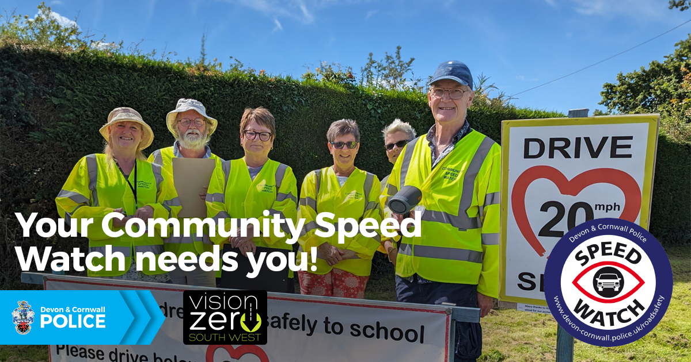

Are you passionate about keeping your community safe?
Looe Community Speed Watch are recruiting new members to discourage people from speeding.
If you would like to make a difference in your town/village and can spare a few hours each month, Looe CSW would love to hear from you.
To find out more about Community Speed Watch, or to apply, visit: https://roadsafety.devon-cornwall.police.uk/community-speed-watch-csw/how-to-join-an-existing-community-speed-watch-group/

